Chapter 4 Heat, light and sound
extra worksheet 1:
Measuring light
Science Understanding Logical/Mathematical Visual/Spatial
Name: Class: Date:
A luminous object produces its own light, whereas a non-luminous object reflects light from another source. For us to see a thing clearly, it must be illuminated by sufficient light. Your eyes are particularly sensitive to yellow-green light (of wavelength 550 nm) and less sensitive to red or blue light. This can be seen in the peak of the curve shown in Figure 1.

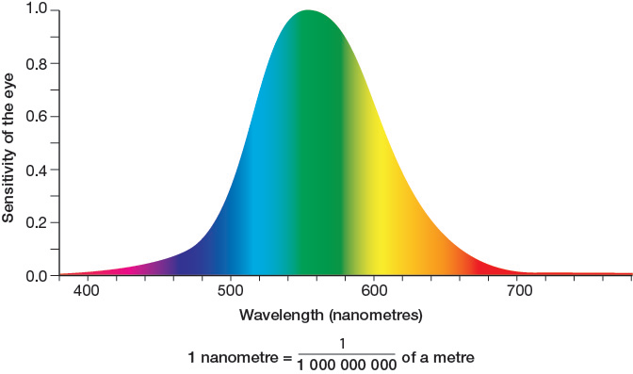
Figure 1 Colour sensitivity of the eye

This means that if a green light and a red light of equal intensity shine towards you, you will see the green light as being brighter. The luminous intensity of a source, measured in a unit called the candela, takes into account the sensitivity of a typical person’s vision to different wavelengths of light. For example, an incandescent 60 W globe appears to have the same luminous intensity as a 9 W compact fluorescent globe. This happens because the incandescent globe emits a lot of heat radiation and less of the colours of the spectrum that the eye is sensitive to compared to the compact fluorescent. (Note that 1 candela is very roughly equal to the light produced by one large candle.)
A light meter measures the illuminance of a source, using a unit called the lux. The illuminance of a source is a measure of the intensity of light falling on a surface per unit area. The approximate illuminance (in lux) of a number of sources is shown in the table below.
Illuminance (lux) | Approximate example
0.00005 | starry night
1 | moonlight
300 | office lighting
400 | sunrise or sunset
1000 | TV studio lighting
1000 | overcast day
32 000–100 000 | direct sunlight

Questions
1 State the unit of measurement of luminous intensity.

2 Recall which frequencies of light the human eye is most sensitive to.

3 Explain why a 9 W compact fluorescent globe appears to have the same brightness as a 60 W incandescent globe.

4 a Define the term illuminance.

b State the unit of measurement of illuminance.

5 Propose why measurements of illuminance are important in:
a sporting arenas in which games are played at night

b professional photography

c comparing visual display units such as televisions and computer screens.

6 Study the recommended light levels for the following environments.
Activity | Illuminance (lux)
working in a classroom | 250
supermarket shopping | 750
working in an operating theatre | 1000
drafting architectural designs | 1500
Discuss why you think these activities differ in the levels of recommended illuminance.

